**Exercise 1: Using Telnet to interact with a Web Server (Unmarked, not to be included in the report)**

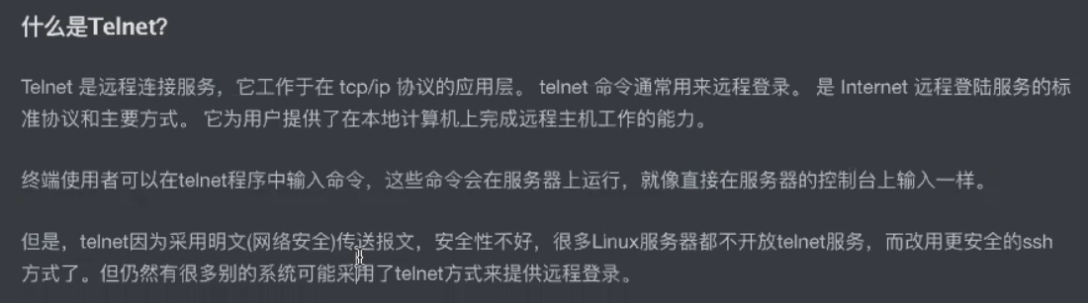

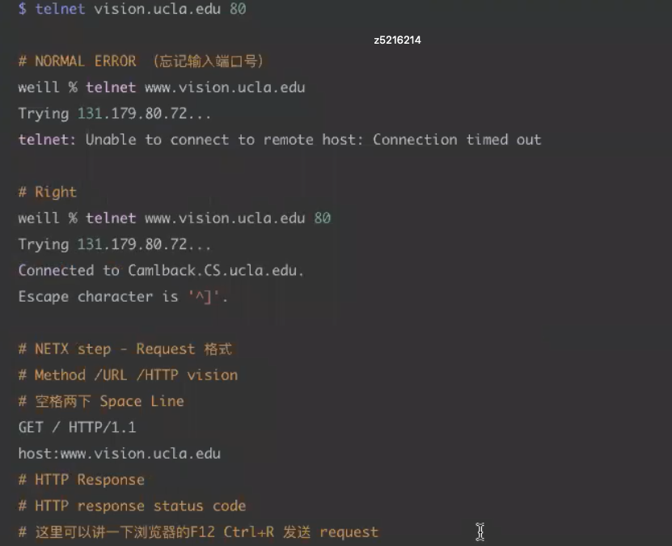

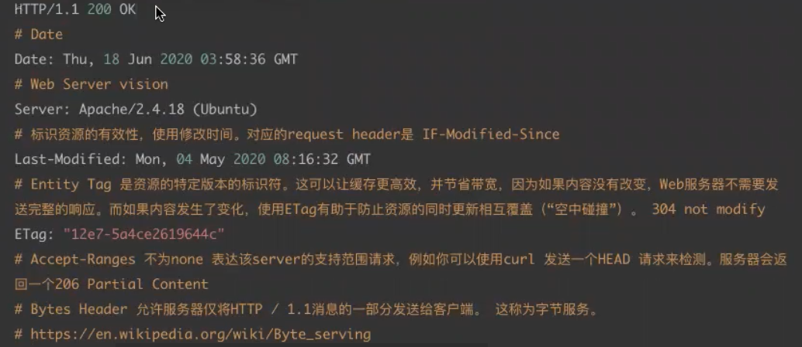

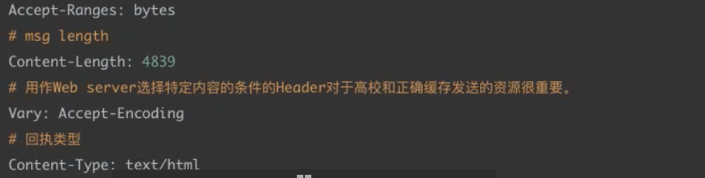

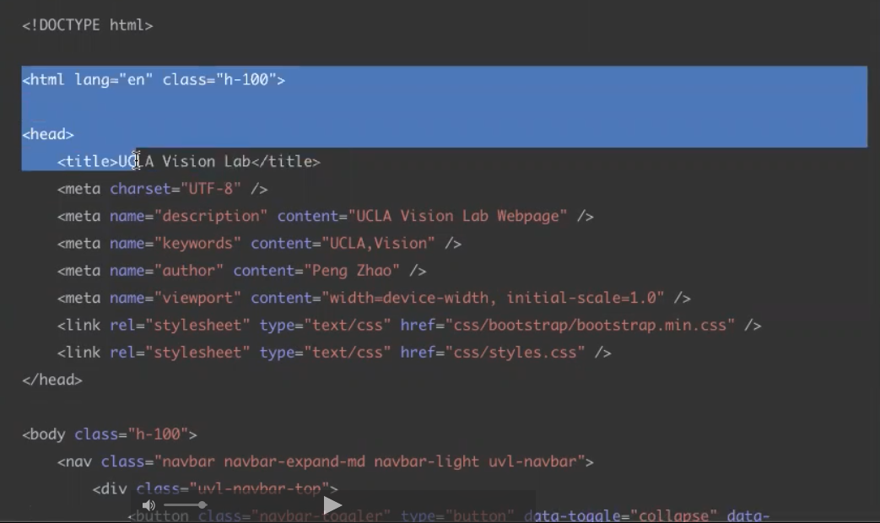

**Step 1:**Open an *xterm*window. Enlarge the size of your *xterm*window so that it is reasonably large and covers almost the entire screen.

**Step 2:**Telnet to the vision.ucla.edu web server by typing:

$ telnet vision.ucla.edu 80

Note that the port number for all web servers is “80”.

**Step 3:**Retrieve the main webpage by typing:

GET / HTTP/1.1

host: [www.vision.ucla.edu](http://www.vision.ucla.edu/)

**Important Note**: You will have to press the carriage return twice after typing the last line.

Question 1: What is the content type of the response? What is the size of the response? When was the webpage last modified? Do you see an "Accept-Ranges" header field? What may this be used for?

**Step 4:**Now execute the HEAD method. When a server receives a request with the HEAD method, it responds with only the message header lines (i.e. the response to the GET method minus the actual requested object).

HEAD / HTTP/1.1

host: [www.vision.ucla.edu](http://www.vision.ucla.edu/)

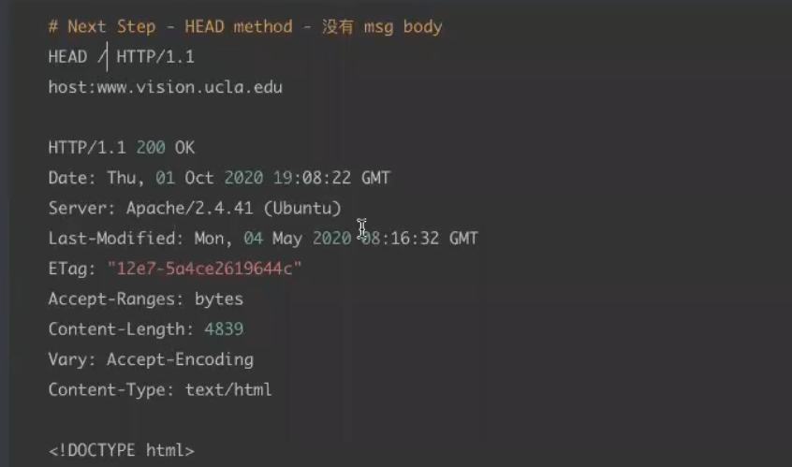

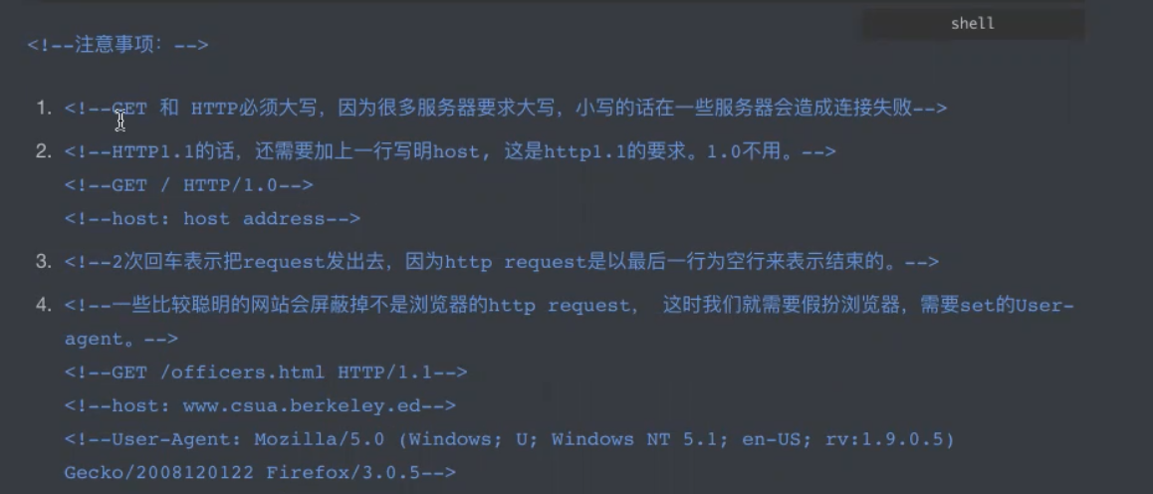

Question 2: What is the content type of the response? What is the size of the response?

Question 3: Using telnet, find a way to get the people.html webpage from vision.ucla.edu

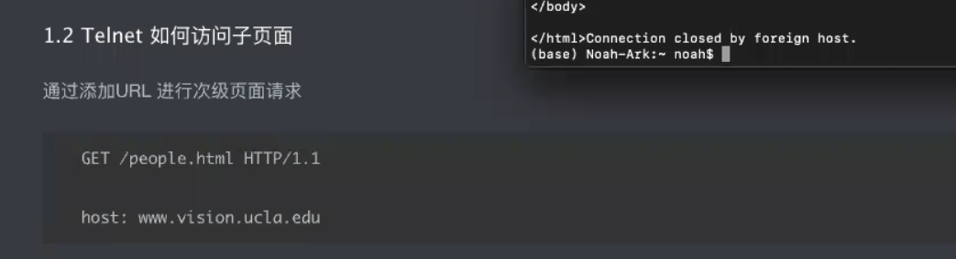

Question 4: Why is there the need to include the host in the GET (and HEAD) HTTP 1.1 request messages?

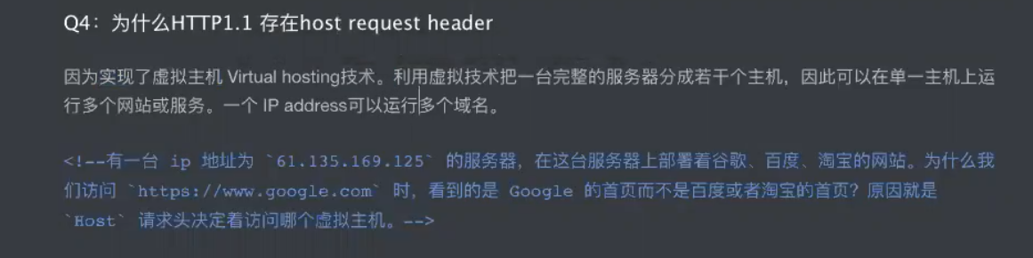

**Exercise 2: Understanding Internet Cookies (unmarked, not to be included in the report)**

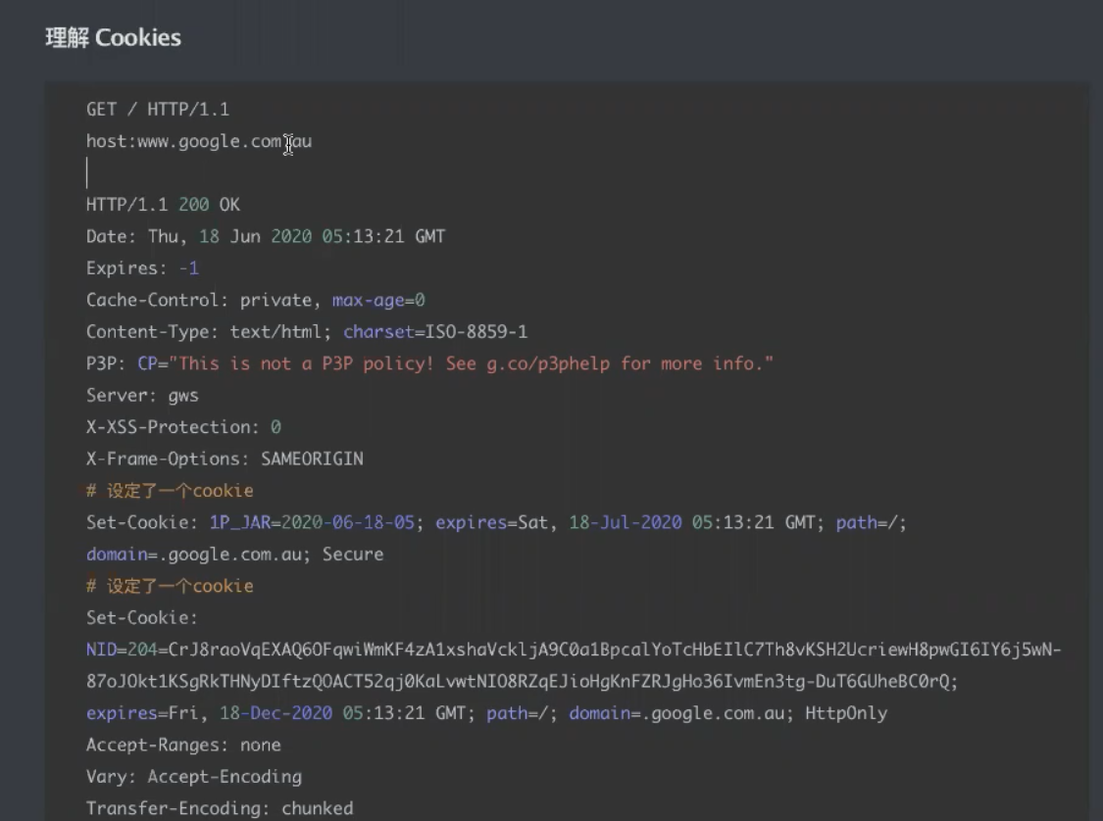



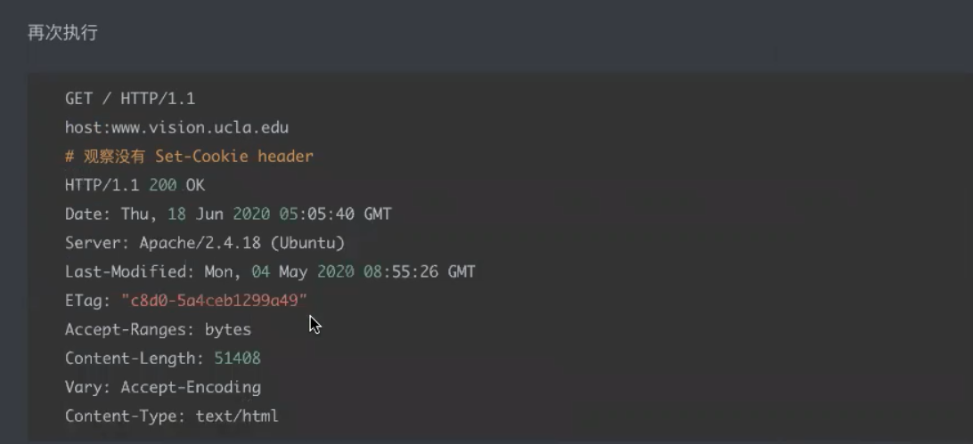

Question 1. Repeat steps 1-3 in the previous experiment for [www.google.com.au](http://www.google.com.au/). Does the site set a cookie in your browser? How can you tell by purely examining the HTTP response message received using telnet? How about www.vision.ucla.edu? Do you think this site will set a cookie in your browser?

Question 2. Open a web browser (Firefox/IceWeasel/Mozilla preferred). Go to the browser preferences and remove all existing cookies. Open the google webpage and then view the cookies. How many cookies are stored on your machine? Which sites installed the cookies?

Question 3. Repeat the above steps for the vision.ucla.edu website. How many cookies are stored on your machine? Which sites installed the cookies? Is the answer inconsistent with the answer for Question 1? Explain why.

**Exercise 3: Using Wireshark to understand basic HTTP request/response messages (marked, include in your report)**

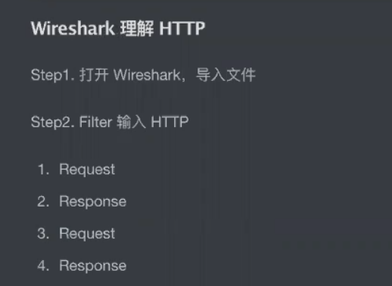

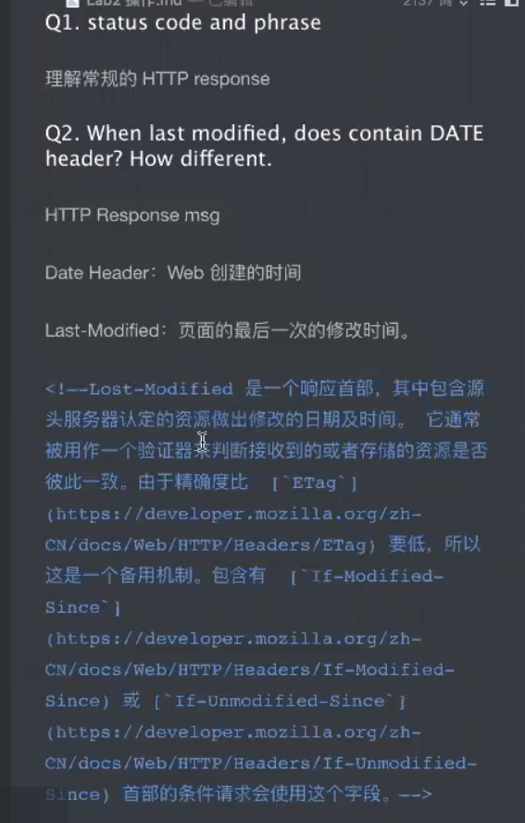

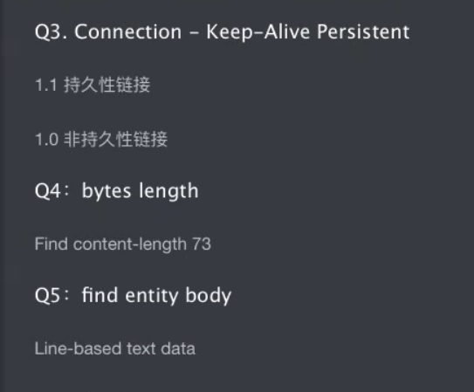

Question 1: What is the status code and phrase returned from the server to the client browser?

Question 2: When was the HTML file that the browser is retrieving last modified at the server? Does the response also contain a DATE header? How are these two fields different?

Question 3: Is the connection established between the browser and the server persistent or non-persistent? How can you infer this?

Question 4: How many bytes of content are being returned to the browser?

Question 5: What is the data contained inside the HTTP response packet?

**Exercise 4: Using Wireshark to understand the HTTP CONDITIONAL GET/response interaction (marked, include in your report)**

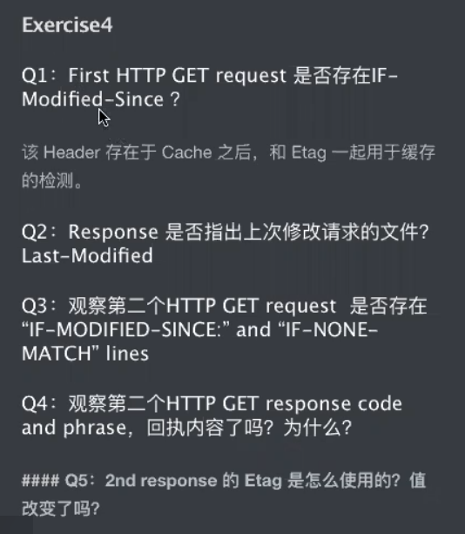

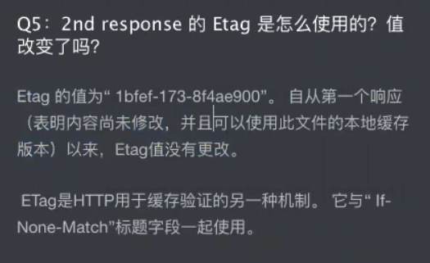

Question 1: Inspect the contents of the first HTTP GET request from the browser to the server. Do you see an “IF-MODIFIED-SINCE” line in the HTTP GET?

Question 2: Does the response indicate the last time that the requested file was modified?

Question 3: Now inspect the contents of the second HTTP GET request from the browser to the server. Do you see an “IF-MODIFIED-SINCE:” and “IF-NONE-MATCH” lines in the HTTP GET? If so, what information is contained in these header lines?

Question 4: What is the HTTP status code and phrase returned from the server in response to this second HTTP GET? Did the server explicitly return the contents of the file? Explain.

 Question 5: What is the value of the Etag field in the 2nd response message and how it is used? Has this value changed since the 1 stresponse message was received?

**Exercise 5: Ping Client (marked, submit source code as a separate file, include sample output in the report)**

